First Congregational Church

United Church of Christ

PO Box 892

Cadillac, MI 49601

***“The Tie that Binds”***

**December 2019**

Newsletter of First Congregational Church UCC

Cadillac, MI

Margie Annis, Music Director

Patrick Delaney, Treasurer

Penny Phelps, Administrator

Marie Linn, Clerk

Rachel Whiteman, Secretary/Organist

Rachel Whiteman, Newsletter Editor

Laura Jacobson-Pentces, Chairperson of Trustees

Church service is Sunday morning 10:30 a.m.

Childcare available.

The church is open on **Mondays and** **Wednesdays** from Noon-2:00 p.m.

Minister: John Doud [pastor@firstcongcadillac.org](mailto:pastor@firstcongcadillac.org) (231) 775-7632

Office email: [office@firstcongcadillac.org](mailto:office@firstcongcadillac.org)

Web Site: [www.firstcongcadillac.org](http://www.firstcongcadillac.org)

**A STEWARDSHIP MESSAGE FROM BILL CINCO**

**My experience with our church started with Sue’s Jazzercise group. There were interim ministers at the pulpit when we first started coming – Forrest and Dani. Then thanks to Dave and Sandy Gaunt and the Search Committee, John Doud was brought to our church. John and Catherine came and Sue and I joined also. John is more than a minister to me; he is a good friend. Soon after we were members, I was asked to join the Trustees. It is a great opportunity to get better acquainted with members and the workings of the church. We have a great board; it’s a positive, hard-working group.**

**Because of my many years in business, I look at things a little differently than some. As a Trustee, I have the opportunity to view the monthly financial statements and I have concerns of maintaining the financial state of the church. The Trustees are charged with the survival of the church as we know it. This includes maintenance, repairs, and the general overhead of the church, just like our homes.**

**As many of you know, we applied for a grant to use towards repair of the steps, railing and ramp at the entrance of the church, as well as a secure door and some wiring concerns. We did not get the grant, but we are looking at other options to accomplish these important goals. The Trustees are looking for any and all ideas or suggestions you may have to offer to help move these projects forward.**

**The Trustees would also welcome any suggestions you can offer about growing our congregation. We need to focus on attracting young people into our church. What changes can we make that would help make this happen? Any and all suggestions you have about fundraising to maintain and address the much-needed repairs to the church would be greatly appreciated. I look at the church as being Mom, and if Mom is not healthy, she is then not able to help others.**

**I would like to recognize several individuals that go above and beyond on behalf of the church:**

**Special thanks to Penny Phelps for all she does. I soon learned if you have a question, she will have the answer.**

**Special thanks to Richard Harvey for all he does to keep the church in working order and maintaining its historical roots.**

**Special thanks to Troy Knight for sharing his technical knowledge with all of the electronic devices and sound system.**

**Special thanks to Margie Annis for all of her years of dedication and support, sharing her great talent of music and friendship with us.**

**We are a very giving church; we donate to several deserving missions and we need to continue that as we have in the past. My personal belief is I want to make a positive difference every day and to learn something new each day as well.**

**I like to remember a quote by our late President John F. Kennedy: “Ask not what your country can do for you; ask what you can do for your country.” I believe it goes much farther than our Country; it applies to everything we do in life.**

**HAPPENING IN DECEMBER:**



*The church will have its famous soup lunch 11:00-2:00*

*available for a donation!*

Keeping it Local

Artists and Crafters Handcrafted Items

Baked Goods

Raffles

Attic Treasures

First Congregational Church

200 E Harris St., Cadillac, MI

December 7, 2019, 10:00 – 3:00 pm

***Handmade Holiday Sale***



Movies for the Mind

“Restriction of free thought and free speech is the most dangerous of all subversions.” – William O. Douglas, Supreme Court Justice

**Won’t you join the conversation?**

Movies for the Mind offers thought-provoking and honest documentaries touching on issues of the body, mind, and spirit. From socially-conscious themes to environmental and political matters, MftM presents films from a wide variety of sources, including independent filmmakers, with messages that matter.

**When**: **Sunday, December 8, 2019** – **Doors open 5:00pm. Movie at 5:30pm.**

**Where**: First Congregational Church Fellowship Hall – 200 E. Harris St

**Cost**: Donation.

**Film snacks:** Bring your own beverage, and any additional movie snacks you would like.Non-GMO popcorn will be available for purchase.

**What to bring**: Some folding chairs will be set up, but if you want to be really comfortable, bring your own seating (lawn chair, pillow, blanket, etc.)

**What to expect:** A film that often entertains, and certainly makes you think. When the film concludes we have an opportunity to share perspectives and reflections on the movie.

**Feature Film**

**Maiden**

We saw this film at the Traverse City Film Festival in July of this year. It is an amazing film that tells the story of a resilient woman and the all-female crew she assembled in 1989, to compete in the Whitbread Around the World Race, considered to be the most dangerous sailing competition on earth. When 26-year-old Tracy Edwards wanted to participate, she was met with resistance and sexism - no team would take her. Left with no other choice, she put together her all-female crew, one who would not only take on the vast and foreboding ocean, but also the doubts and attacks from her male competitors and press. In this incredible true story, watch Edwards and her crew attempt to turn the impossible into reality as they take on fifty-foot waves, icebergs and all of the dangers of the great and powerful sea. ***MAIDEN*** is a stunning, emotional film that celebrates the strength and resilience of women.

Join us to celebrate the power of women as Tracy Edwards leads the first all-female crew in the Whitbread Round the World Race, a grueling yachting competition that covers 33,000 miles and lasts nine months.

The Advent season begins Sunday, December 1. There will be special readings and candles will be lit during the 10:30 worship service each Sunday during Advent.



A Cadillac First Congregational UCC tradition will continue with the hanging of the Christmas ornaments and tree decorating during the **December 8** worship service.

This is fun for ALL ages!!!

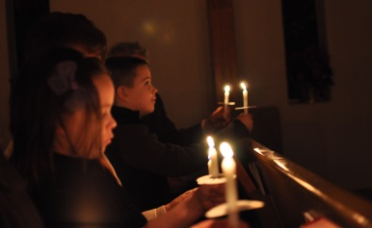The Christmas Eve service will be held **Tuesday, December 24 at 7:00 p.m**. in our sanctuary. This is a beautiful candle-lit service; no better way to await the birth of Christ.

We hope your family will be able to come together here that evening and share in the music and mystery of His birth.

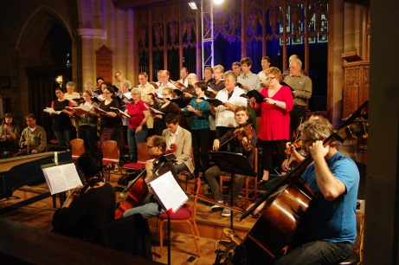 First Congregational Church UCC, Cadillac will once again be hosting Cadillac Community Messiah Singalong on **Sunday, December 29 at**

**3:00 p.m.**

The chorus will be accompanied by an orchestra comprised of local musicians. All are welcome to come along to sing or listen

**WHAT’S BEEN HAPPENING:**

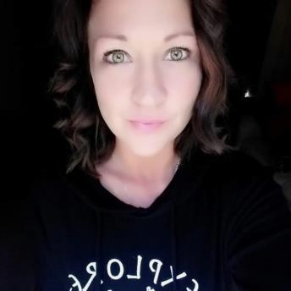 Meet our new housekeeper, Heather Thompson. Heather was born and raised in Cadillac. She spent the last seven years living and working in Traverse City but has recently returned 'home' to Cadillac.

Heather is a Mom to one son. She states, “She has a wonderful boyfriend.” Heather loves animals and nature. She says, “Nothing beats the sunsets over Lake Michigan!” Heather has two dogs and two cats. She enjoys doing photography. Heather loves her work cleaning. Yes, you heard that right. Heather loves to clean!

Welcome Heather!

**HARVEST FEAST PHOTOS**

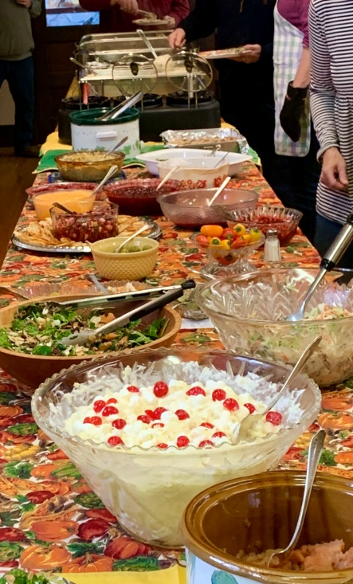

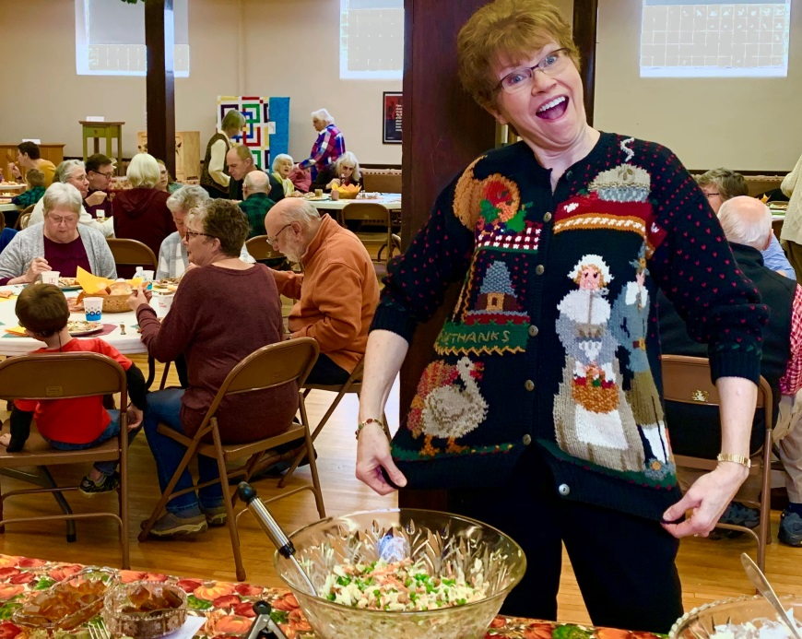

**BOARD OF TRUSTEES** - Laura Jacobson-Pentces

Highlights of the November BOT Regular Meeting

The Board of Trustees met at the home of Angie Brugger on November 11, 2019. This was the second work session for the board - the first work session was in October. The first portion of the November work session served as the regular monthly board meeting, with the afternoon dedicated to solidifying and reviewing church rental policies for groups wanting to use the sanctuary and/or fellowship hall. In addition, the board is reviewing different avenues for fund raising to meet future infrastructure needs and updates.

Items from the regular meeting:

*The board addressed concerns raised at the semi-annual meeting regarding donations/pledges to specific line items of the budget. In an effort to improve transparency and accountability, the pledge cards were modified this year, and the board had a considerable discussion about that new format. The board discussed items regarding this issue to be addressed at the Annual Meeting to be held on February 2 2020.

*Cleaning Services. Hope Network will no longer be cleaning the church. The board and church administrator have worked for many years with the team leaders that accompany the workers, but this has not had a satisfactory outcome. A new cleaning service is being used, on a trial basis.

Pulpit Supply for 2020: Pastor John Doud shared his calendar for 2020, and the Board approved either Judy Coffey or Deb Johnson as guest speakers for those dates. The board greatly appreciated the pastor's long range planning!

Harvest Dinner: The board talked turkey and is assisting Penny Phelps with the dinner.

Laura Jacobson-Pentces

**It’s time to order poinsettias for the sanctuary!**

**If you wish to join in this time-honored tradition of purchasing a plant to create a blaze of color at the front of the sanctuary, please fill in the form below and either bring it to church or mail it in.**

**The deadline is Sunday, December 15th.**

**Poinsettia Order**

**I/We ________________________________________ wish to order**

(Name)

**_______ poinsettias at $8 each in memory / honor (circle one) of:**

**_________________________________________________________.**

**Enclosed is my/our payment of $_____________.**

***Happy Holidays!***

***from First Congregational Church UCC, Cadillac!***

**2019 MISSIONS**

Jan.: Our Church’s Wider Mission, Feb.: After 26 Project, March: One Great Hour of Sharing,

April: Love, INC, May: Strengthen the Church, June: New Hope Shelter, July: Back Pack Program, August: Stehouwer Free Clinic, Sept.: Feeding America, Oct.: Neighbors in Need, Nov.: Salvation Army, Dec.: Christmas Fund

|  |  |  |  |  |  |
| --- | --- | --- | --- | --- | --- |
| **DECEMBER SUNDAY MORNING SCHEDULE** | | | | | |
| **Date** | **Greeters/ Ushers** | **Liturgist** | **Fellowship Hr** | **Sexton** | **Preacher** |
| **1** | **Gert & Sperry Claypool** | **Penny Phelps** | **Penny Phelps, Charlotte Barfield** | **George Davis** | **Robin Corbin** |
| **8** | **Tom & Diane Jobson** | **Robin Corbin** | **Laura Porter & Karl** | **Tom Jobson** | **John Doud** |
| **15** | **Joyce & Mike Oatley** | **George Davis** | **Ted Parkhurst +1** | **Don Liebau** | **John Doud** |
| **22** | **Sandie & Brie Post** | **Don Liebau** | **Don & Nancy Liebau** | **Joyce Oatley** | **John Doud** |
| **29** | **George Davis & Leif Williams** | **Karen Anderson** | **Karma Chapo** | **Karma Chapo** | **Penny Phelps** |

|  |  |  |  |  |  |  |
| --- | --- | --- | --- | --- | --- | --- |
| **DECEMBER 2019 CHURCH CALENDAR** | | | | | | |
| **Sunday** | **Monday** | **Tuesday** | **Wednesday** | **Thursday** | **Friday** | **Saturday** |
| **1 Choir 9:30am**  **Worship 10:30am:**  **Communion (circle)** | **2**  Office 12-2pm | **3** | **4**  Office 12-2pm  Choir 7pm | **5** | **6** | **7**  **10am-3pm BAZAAR/CRAFT SALE** |
| **8 Choir 9:30am**  **Worship 10:30am**  **HANGING OF THE ORNAMENTS** | **9**  Office 12-2pm | **10** | **11**  Office 12-2pm  Choir 7pm | **12** | **13** | **14** |
| **15**  **Choir 9:30am**  **Worship 10:30am:** | **16**  **10am Board of Trustees**  **Office 12-2pm** | **17**  ***NEWSLETTER DEADLINE*** | **18**  Office 12-2pm  **Choir 7pm** | **19** | **20** | **21** |
| **22**  **Choir 9:30am**  **Worship 10:30am** | **23** Office 12-2pm | **24**  **7PM CHRISTMAS EVE SERVICE** | **25**  **CHRISTMAS DAY** | **26** | **27** | **28** |
| **29**  **Worship 10:30am**  **3pm MESSIAH SINGALONG** | **30**  Office 12-2pm | **31** | **DECEMBER Mission: Christmas Fund (UCC)** |  |  |  |

**NON-CHURCH ACTIVITIES THAT TAKE PLACE IN THE CHURCH BUILDING:**

**Jazzercise**: 8:30am: Tue, Thu, Fri, Sat; 5:45pm: Mon, Wed, Thu; 4:30: Wed. **Yoga** (Sandy Gaunt): Wednesdays 10am