First Congregational Church
United Church of Christ
PO Box 892
Cadillac, MI 49601

“The Tie that Binds”

January/February 2020

Newsletter of First Congregational Church UCC

Cadillac, MI
Margie Annis, Music Director
Patrick Delaney, Treasurer
Penny Phelps, Administrator
Marie Linn, Clerk
Rachel Whiteman, Secretary/Organist
Rachel Whiteman, Newsletter Editor
Laura Jacobson-Pentces, Chairperson of Trustees

Church service is Sunday morning 10:30 a.m.
Childcare available.
The church is open on Mondays and Wednesdays from Noon-2:00 p.m.
Minister: John Doud pastor@firstcongcadillac.org (231) 775-7632
Office email: office@firstcongcadillac.org

Web Site: www.firstcongcadillac.org

FRITH ON EARTH

One of my favorite television shows was a series on Masterpiece Theater called “I Claudius.” It was all about the personal lives of the first four Roman Emperors. Brian Blessed played a character who was honored as Lord and called “Son of God.” This character was hailed as a bringer of peace. He was proclaimed as the savior of the world and worshipped all over the known world. That’s right…Brian Blessed played Gaius Julius Caesar Augustus. Born 63 years before Jesus, Caesar Augustus had earned those titles through his successes in unifying an empire rent by civil war, rebuilding Rome physically and politically, enlarging her territories, and increasing her influence over the known world. There was no one more powerful and important in the world than Caesar Augustus (except for his plotting wife Livia, but that’s another story). But a baby born in a forgotten outpost of the Roman Empire would change that forever.

For those under the rule of Rome, Caesar was considered a god. He had power over every aspect of their lives. He stands tall as one of the most significant leaders in human history. The month in which I was born is named after him, and yet not a single person calls him “Lord” today, while over two billion people call Jesus, who was born an insignificant Jewish peasant, Lord and Savior.

According to our Christmas stories, with a mere decree from Augustus, a pregnant Mary, and harried Joseph are sent scurrying like ants from a disturbed hill. Caesar’s desire to number his subjects will force them out on the open road in the final days of her pregnancy. His thirst for tax revenue will force Mary to give birth in a stable. By all accounts and appearances, Rome pulls the strings and her people are merely puppets.

Of course, God was really in charge. The mighty emperor’s edict simply serves God’s purpose to fulfill the prophecy in Micah that the Messiah would be born in Bethlehem. As the Christmas story unfolds, we see that the emperor is merely a pawn in a chess game and that he will lose to a baby. His titles cannot outlive him. His powers die with him and his glory soon fades. But not so for the child.

So who is Lord? Is it the one who demands our obedience by fear and law or is it the one who invites us to his lowly manger and captures our hearts with humility? We are the shepherds who come and marvel, and then leave rejoicing. The circumstances of Jesus’ birth remind us that the leaders who inspire the greatest loyalty earn it by sharing the troubles and trials of their followers.

This was radical. Most Jews were looking for a Messiah who would pick up a sword and destroy his enemies. But God’s Messiah urged us to put down the sword, love our enemies, and do good to those who hate us.

So many earthly rulers make the same mistake. They think they know how to win the game. They think that the goal in life is like the aim in Monopoly: more power, more money, more land, to get more glory. To win a game of Monopoly, one has to choose greed and thus wind up with enemies. But Jesus played the game where the goal was God’s kingdom and the rules were love.

Who is the bringer of peace? Is it the one who crushes all resistance with an iron boot? The Pax Romana – our word for peace is Latin and it comes from “Pax” while the ancient English word for peace was “frith” – and the time of peace and prosperity ushered in by Augustus was indeed a boon for Romans, but not so much for those countries like Israel, which suffered as the Romans flourished. The bringer of peace is not the one who allows injustice to flourish as long as a select few benefit.

So during this Christmas season, remember the greatest gift of all, “for to you is born this day in the city of David a Savior who is Christ the Lord.” Merry Christmas!!

The Reverend Vaughn Peterson
First Congregational Church, Harrison
EVENTS IN JANUARY & FEBRUARY:

Movies for the Mind

“Restriction of free thought and free speech is the most dangerous of all subversions.” – William O. Douglas, Supreme Court Justice

Won’t you join the conversation?

Movies for the Mind offers thought-provoking and honest documentaries touching on issues of the body, mind, and spirit. From socially-conscious themes to environmental and political matters, MftM presents films from a wide variety of sources, including independent filmmakers, with messages that matter. Films presented have won major awards at festivals ranging from the Traverse City Film Festival to Sundance and more.

When: Sunday, January 19, 2020. Doors open 5:00pm. Movie 5:30pm.

Where: First Congregational Church Fellowship Hall – 200 E. Harris St
(Across from the Cadillac Post Office)
Cost: Donation.

Film snacks: Bring your own beverage, and any additional movie snacks you would like. Non-GMO popcorn will be available for purchase.

What to bring: If you want to be really comfortable, bring your own seating (lawn chair, pillow, blanket, etc.) Some folding chairs will be set up but moving to more comfortable arrangements is recommended.

What to expect: A film that often entertains, and certainly makes you think. When the film concludes we have an opportunity for people to share their perspectives and reflections on the movie.
Feature Film
Briars in the Cottonpatch

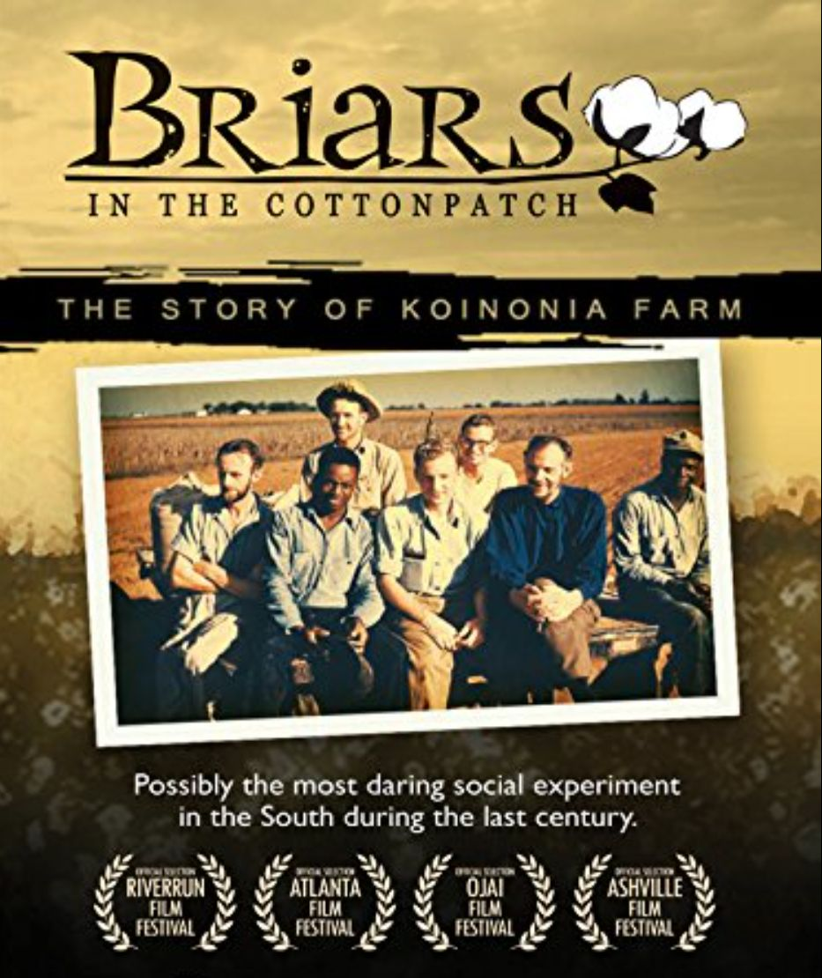

Have you ever heard of Koinonia? If so, at the film’s end you can share how and when you were made aware of this courageous social experiment. If not, then come along on this film journey and learn about an important undertaking from the past……….and present.
Possibly the most daring social experiment in the South during the last century, Koinonia Farm faced years of terror, boycotts and intimidation in the years leading up to the tumultuous Civil Rights era. This award-winning documentary is a compelling chronical of heroic humility and uncommon courage. Interestingly, Koinonia Farm was the catalyst for the Habitat for Humanity movement.
This film sets the tone for Martin Luther King Jr day on January 20, 2020. Join us as we recognize the impact of courageous pioneers of the Civil Rights Movement.

SPROUTING CLASS Sandy Gaunt

There will be a Sprouting Class Sunday January 12 at 12:30 in Fellowship Hall . Sprouting is a part of the Hippocrates Lifestyle. Hippocrates is a non-profit health institute located in West Palm Beach, Florida where people have gone to learn how to achieve and maintain optimal health for over 6 decades. When we sprout seeds it unleashes their full potential which is needed to grow into a viable plant. This is when the nutritional value, and therefore the health benefit is the greatest. In this class we will be exploring the many different ways to sprout as well as the benefits of the different types of seeds.

ANNUAL MEETING

This year’s Annual meeting will take place after worship on Sunday February 2, 2020.
Please submit reports to office@firstcongcadillac.org.

WHAT’S BEEN HAPPENING:

HANGING OF THE ORNAMENTS
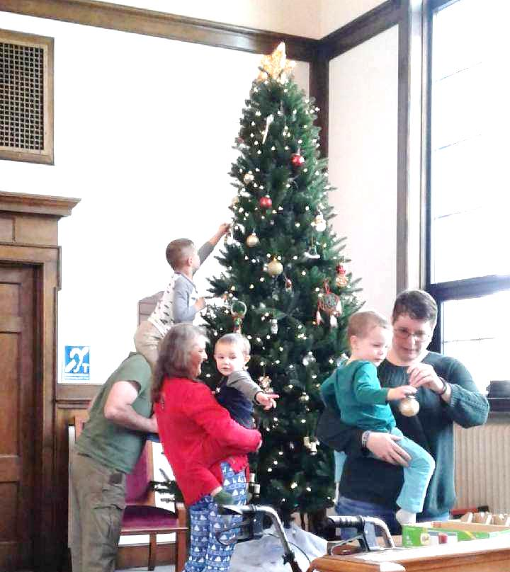
DECEMBER’S CRAFT SHOW AND LUNCHEON

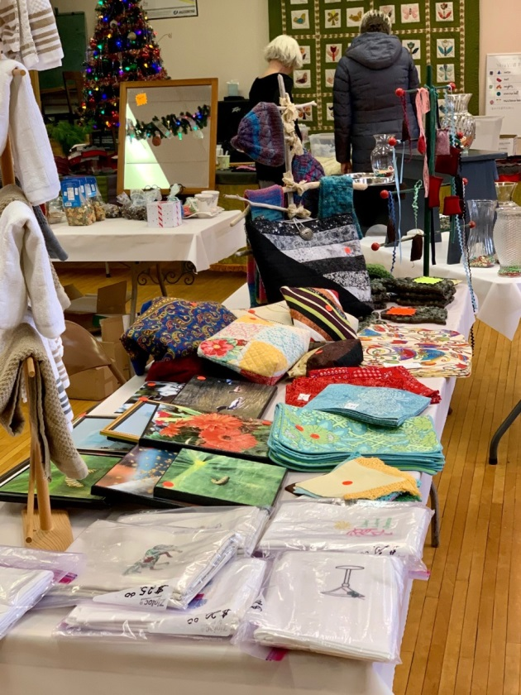
Following many months of planning, on Saturday, Dec. 7th, we had a very successful “Holiday Handmade Craft Show and Luncheon.”
Although the number of vendors was down, Fellowship Hall was well-filled with tables. Shari Spoelman had her usual array of skirts and tops and scarves. Sandy Gaunt had a table full of teas and tinctures, and Ted Parkhurst set up a table of books from his publishing company.
One of the big draws was an extensive display of attic treasures. The bake sale table was also popular, and the church craft table included many artistic creations from photos to embroidered napkins and towels, to wall hangings made of Michigan outlines filled with Frankfort green stone, to knitted items and tote bags.
There was also a raffle of a variety of items: hand-carved plates depicting the church steeple, a sturdy stool and a raised dog feeding station, and other goodies.
The soup luncheon was a great success, and raffle tickets for “the big items” were in demand.

All of this has only been possible thanks to many volunteers. Creators included Troy Knight, Sara Keineth, Linda Baynes, Richard Harvey, Karma Chapo, Tom and Diane Jobson, Gary Van Houten and Shari Spoelman. Movers and shakers were Don Liebau, Richard Harvey, Sandy Gaunt, Shari Spoelman, Marie Linn, and Margie Annis. Manning tables and stirring pots were Kathy Bloomfield, Diane Jobson, Nancy Liebau, Laura Jacobson-Pentces, Marie Linn, Rachel Whiteman, and Laura Porter. Our thanks also go to all those folks who donated “attic treasures” and who created goodies for the bake sale.

A special thank you goes to Karen Anderson for creating a flyer about the raffle items. Through the wonders of modern technology, she was able to put this together while basking in smoke-filled California. We also appreciate the efforts and talents of Shari Spoelman and Rachel Whiteman who spread the word via Facebook.

By the end of coffee hour on Sunday, the total income from all sources (vendor fees, baked goods, attic treasures, church crafts, luncheon, and Ted’s books) was over $1,200 – not counting raffle tickets! When the raffle is held on Dec. 31st, the total from all of our efforts will be over $2,000. We are hoping that this money can be used to establish a fund to replace our sign with one that is easier to read and makes it clear who we are.
Penny Phelps

Here are some approximate figures:
One-day raffle tickets $ 48, Luncheon $ 217, Vendors fees $ 75, Ted Parkhurst’s books $ 65, Bake Sale $ 139, Church crafts $ 210, Attic Treasures $ 455
TOTAL $1,209

BOARD OF TRUSTEES - Laura Jacobson-Pentces

Highlights of Board of Trustees Meeting - December 16, 2019:

The board met on December 16 for their last regular meeting of 2019. Items of interest included:

1) Church cancellation policy . The board discussed the need to review the current procedure for the cancellation of church due to inclement weather. Board members will confer with the Church Administrator, and the pastor and determine if church services need to be cancelled. If so determined, the board members and the church administrator will use a phone tree to notify congregants that church is cancelled, by 8:30 AM. In addition, congregants are encouraged to check 9&10 News Closings (either on the 9&10 website or their app) or to contact a board member or the church, to inquire if church is cancelled.

2) Update on Pledge Response. The stewardship committee relayed that as of Dec. 13, there are 29 pledges, totaling $57.690. For reference, 2018 had 38 pledges, totaling $70,655. The proposed budget for 2020 is approximately $100,000.

3) Update on architect plan for ADA Ramp and Improvements to front of church and entryway . Stephanie White, an architect whose firm specializes in historic renovation, will present the board (and the congregation) with a plan for incorporating a ramp that is ADA (Americans with Disabilities
Act) compliant as well as in keeping with the historical nature of the church. Her plan will also include front entryway designs that will allow for barrier free access, as well as updates/improvements to the facade of the building and the signage - with special attention to the historical nature of the church and in keeping with its Federalist design.
The board is committed to moving ahead with these plans and for developing a long range master plan that includes plans for major rehab work projects. The goal of this plan is to provide a well thought out guide for future projects and to use this plan when applying for future funding. The board is looking at a variety of possible funding sources for future improvements, including the possibility of pursuing designation as a National Historic Register Site. The board is currently in the initial
stages of investigation of the requirements of this process.

4) Funds raised by Holiday Bazaar to be designated for future front sign revision/revamp. The Holiday Bazaar, held on December 7, raised over $1000. Kudos to all those that helped, donated and volunteered. The money raised from this will be used to redo/revamp the front sign. In keeping with the plans to preserve the historical integrity of the church, the board will look at the suggestions provided by the architect, and present these to the congregation for discussion. Final approval of the
sign will require a congregational vote.

5) Christmas Eve Service. The board discussed the need for a Sexton to cover the Christmas Eve Service.

LOOKING AHEAD:

SAVE THE DATE
The Gathering (UCC Women of Michigan) will take place on June 12, 13 & 14 2020 at Kettunen Center, Tustin. Keyonte speaker: Rev Jody Betten, pastor of new church start “New Waves UCC” in Traverse City.

JANUARY SUNDAY MORNING SCHEDULE
Date | Greeters/ Ushers | Liturgist | Fellowship Hr | Sexton | Preacher
5 | Carol & Jerry Nilsson | Laura Porter | Volunteers needed | Laura Jacobson-Pentces | Judy Coffey
12 | Linda Baynes & Penny Phelps | Don Liebau | Diane and Tom Jobson | Richard Harvey | John Doud
19 | Dave & Sandy Gaunt | Catherine Doud | George Davis, Leif Williams + Matthew | Dave Gaunt | John Doud
26 | Gert & Sperry Claypool | Robin Corbin | Patrick Delaney | Patrick Delaney | John Doud

JANUARY 2020 CHURCH CALENDAR
Sunday | Monday | Tuesday | Wednesday | Thursday | Friday | Saturday
JANUARY Mission: Our Church’s wider Mission (UCC) |  |  | 1  NEW YEAR’S DAY | 2 | 3 | 4
5 Choir 9:30am  Worship 10:30am:  Communion (pew) | 6  Office 12-2pm | 7 2:00pm  Bequests  Committee | 8  Office 12-2pm  Choir 7pm | 9 | 10 | 11
12  Choir 9:30am  Worship 10:30am:  12:30 Sprouting Class – Sandy Gaunt | 13  Office 12-2pm | 14 | 15  Office 12-2pm  Choir 7pm | 16 | 17 | 18
19  Choir 9:30am  Worship 10:30am  Movies for the Mind 5pm for 5:30pm | 20 10am Board of Trustees  Office 12-2pm  NEWSLETTER DEADLINE | 21 | 22  Office 12-2pm | 23 | 24 | 25
26  Worship 10:30am | 27  Office 12-2pm | 28 | 29  Office 12-2pm  Choir 7pm | 30 | 31

2020 MISSIONS

Jan.: Our Church’s Wider Mission, Feb.: After 26 Project, March: One Great Hour of Sharing,
April: Love, INC, May: Strengthen the Church, June: New Hope Shelter, July: Back Pack Program, August: Stehouwer Free Clinic, Sept.: Feeding America, Oct.: Neighbors in Need, Nov.: Salvation Army, Dec.: Christmas Fund

FEBRUARY SUNDAY MORNING SCHEDULE
Date | Greeters/ Ushers | Liturgist | Fellowship Hr | Sexton | Preacher
2 | Gert & Sperry Claypool | Penny Phelps | Volunteers needed | Joyce Oatley | John Doud
9 | Mike & Joyce Oatley | Tom Jobson | Volunteers needed | Tom Jobson | Deb Johnson
16 | Don & Nancy Liebau | George Davis | Volunteers needed | Don Liebau | John Doud
23 | Sandie & Brie Post | Joyce Oatley | Volunteers needed | Angie Brugger | John Doud

FEBRUARY 2020 CHURCH CALENDAR
Sunday | Monday | Tuesday | Wednesday | Thursday | Friday | Saturday
FEBRUARY Mission: After 26 Project |  |  |  |  |  | 1
2 Choir 9:30am  Worship 10:30am:  Communion (circle)  11:30 ANNUAL MEETING | 3  Office 12-2pm | 4 | 5  Office 12-2pm  Choir 7pm | 6 | 7 | 8
9  Choir 9:30am  Worship 10:30am: | 10  Office 12-2pm | 11 | 12  Office 12-2pm  Choir 7pm | 13 | 14 | 15
16  Choir 9:30am  Worship 10:30am | 17 10am Board of Trustees  Office 12-2pm  NEWSLETTER DEADLINE | 18 | 19  Office 12-2pm | 20 | 21 | 22
23  Worship 10:30am | 24  Office 12-2pm | 25 | 26  Office 12-2pm  Choir 7pm | 27 | 28 | 29

NON-CHURCH ACTIVITIES THAT TAKE PLACE IN THE CHURCH BUILDING:

Jazzercise: 8:30am: Tue, Thu, Fri, Sat; 5:45pm: Mon, Wed, Thu; 4:30: Wed.
Yoga (Sandy Gaunt): Wednesdays 10am

